Project Design Phase-II
Data Flow Diagram & User Stories

Date | 08/03/2026
Team ID | 69a7b679fa5736d932f64257
Project Name | Product Inventory Management
Maximum Marks | 4 Marks

Data Flow Diagrams:
A Data Flow Diagram (DFD) is a traditional visual representation of the information flows within a system. A neat and clear DFD can depict the right amount of the system requirement graphically. It shows how data enters and leaves the system, what changes the information, and where data is stored.
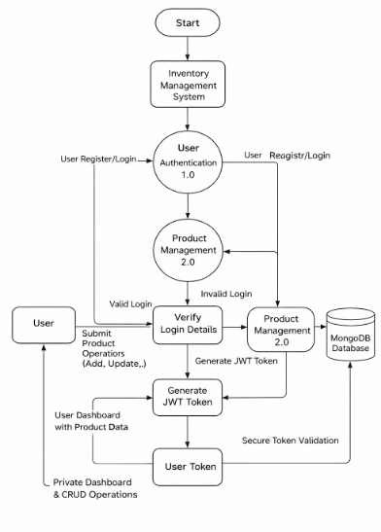
User Stories
Use the below template to list all the user stories for the product.
User Type | User Story Number | User Story / Task | Acceptance Criteria | Priority | Release
Customer (Web User) | USN-1 | As a user, I can register and log in securely using JWT authentication | User can create account and receive token after login | High | Sprint-1
Customer (Web User) | USN-2 | As a user, I can add new products to my inventory | Product is saved and visible only to logged-in user | High | Sprint-1
Customer (Web User) | USN-3 | As a user, I can view all my products in a dashboard | Products load successfully with valid token | High | Sprint-1
Customer (Web User) | USN-4 | As a user, I can update product details like price and quantity | Changes are saved and reflected instantly | Medium | Sprint-2
Customer (Web User) | USN-5 | As a user, I can delete products from my inventory | Product disappears from dashboard after deletion | Medium | Sprint-2
Customer (Web User) | USN-6 | As a user, I can search products by name | Filtered results appear based on keyword | Low | Sprint-2

